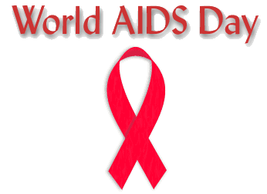

On World AIDS DAY spread Awareness
about AIDS Prevention and Saving lives.

In honor of those living with HIV and AIDS, and in the memory of those we have lost to AIDS.

